TP 02

How to use commit , savepoint and Rollback

**Supervised :**

**professeur Ouared abdelkader djilali**

**Presented :**

**Rahlaoui Lahcen**

**Lebani Ali Zakaria**

**Laoumir Mustapha Abdelkader**

The process is a set of modifications that take place in the database according to a logical sequence, and it results in some changes in the rule such as deleting a record, modifying data or creating a new record, and these changes become a permanent part of the database if it is completely implemented without errors, but in the event that any Error, we have to go back to the previous version .

There are three process control commands:

COMMIT : Save changes .

ROLLBACK : To return and restore the previous data in its old state .

SAVEPOINT : Make backup copies on groups in order to restore data .

We will see how to use those commands in mysql

* First thing first run XAMPP and then start the mysql

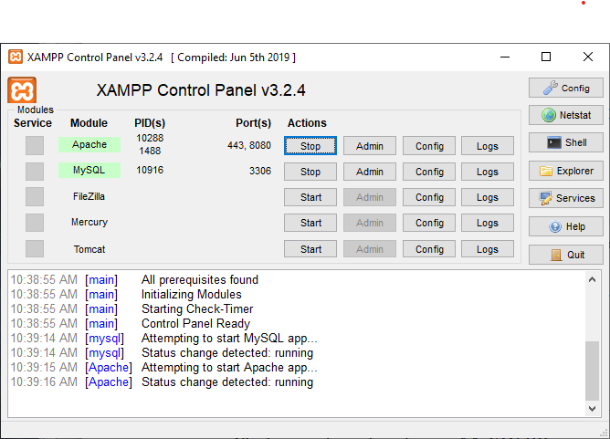

* Open navicat for Mysql

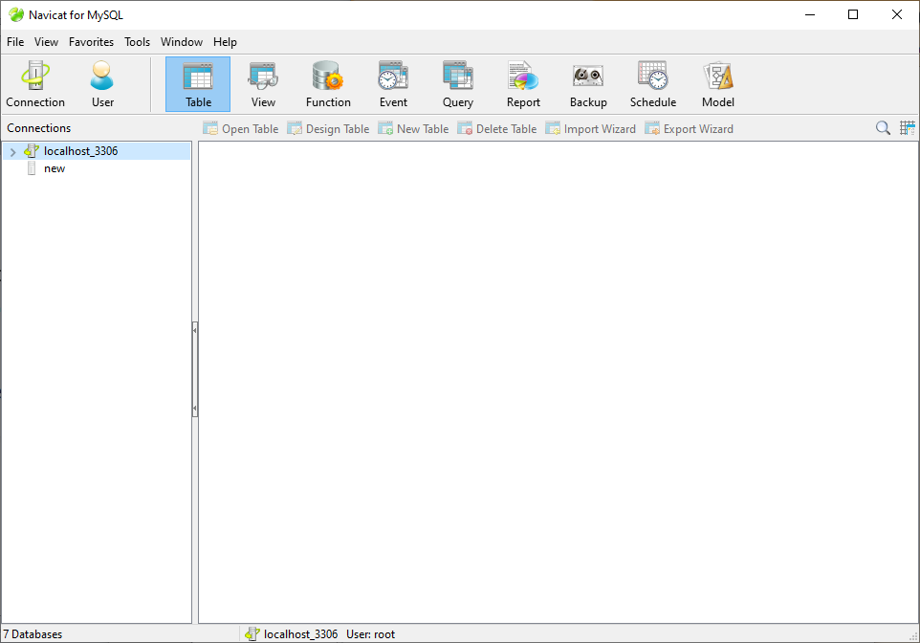

* Double click on « Localhost_3306 »

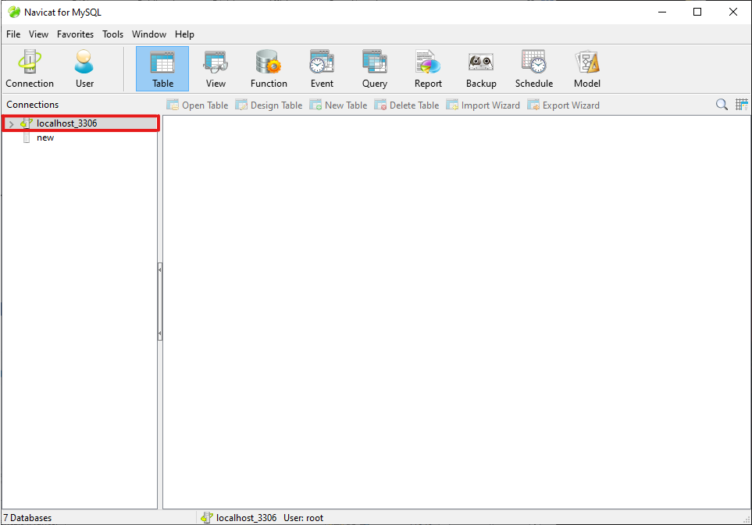

* Then right-click on "localhost_3306" and select the option new Database…

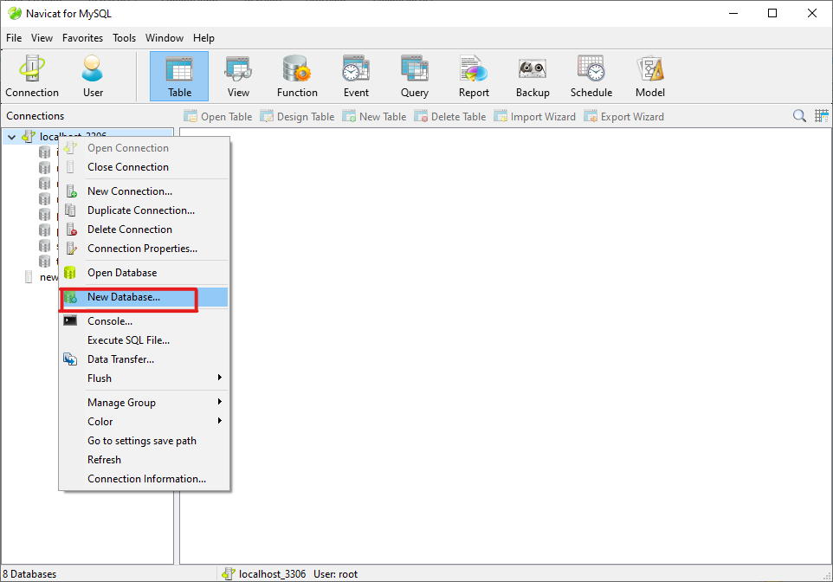

* Pick a name for this database

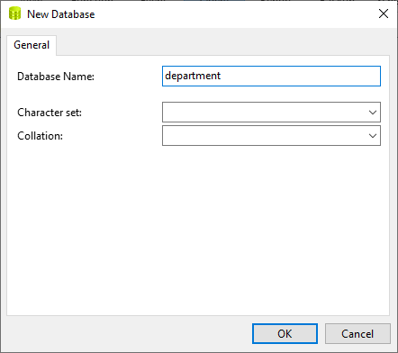

* The select the database “Department” and select query and click on new query

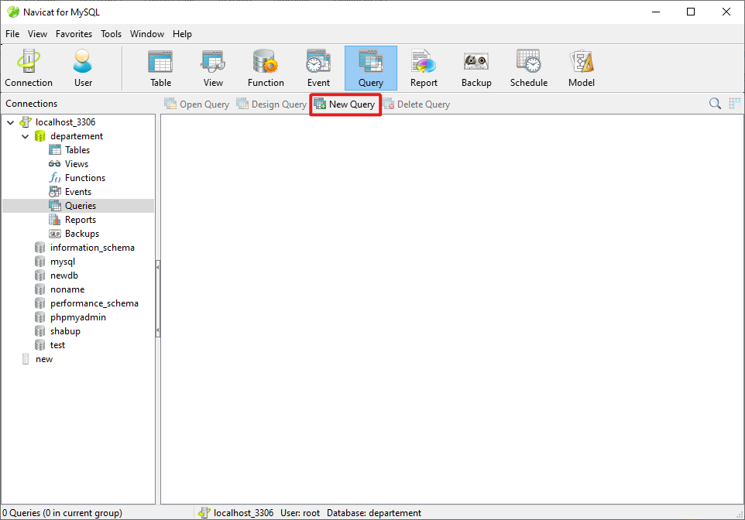

* Create a table using the sql language , and run the code

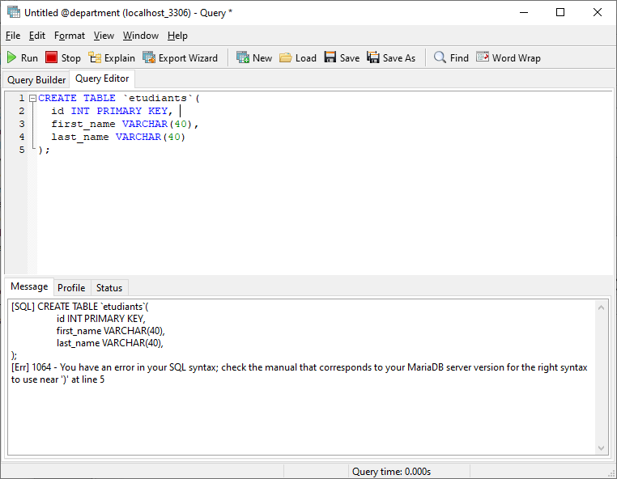

* The table is created successfully

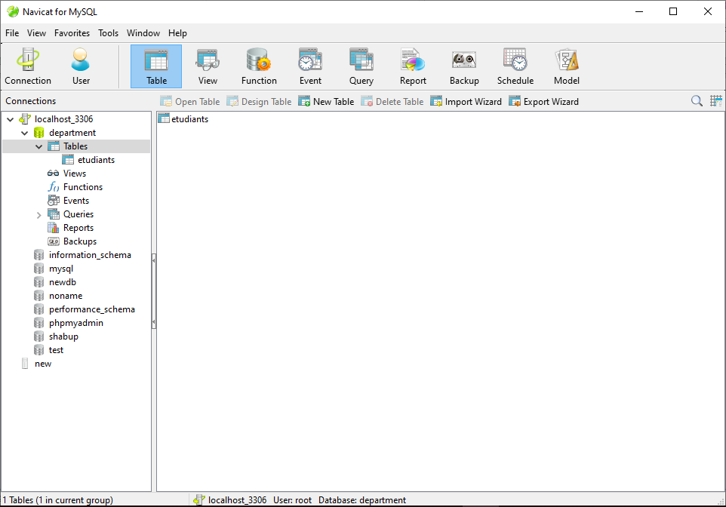

* Now we will use the control commands

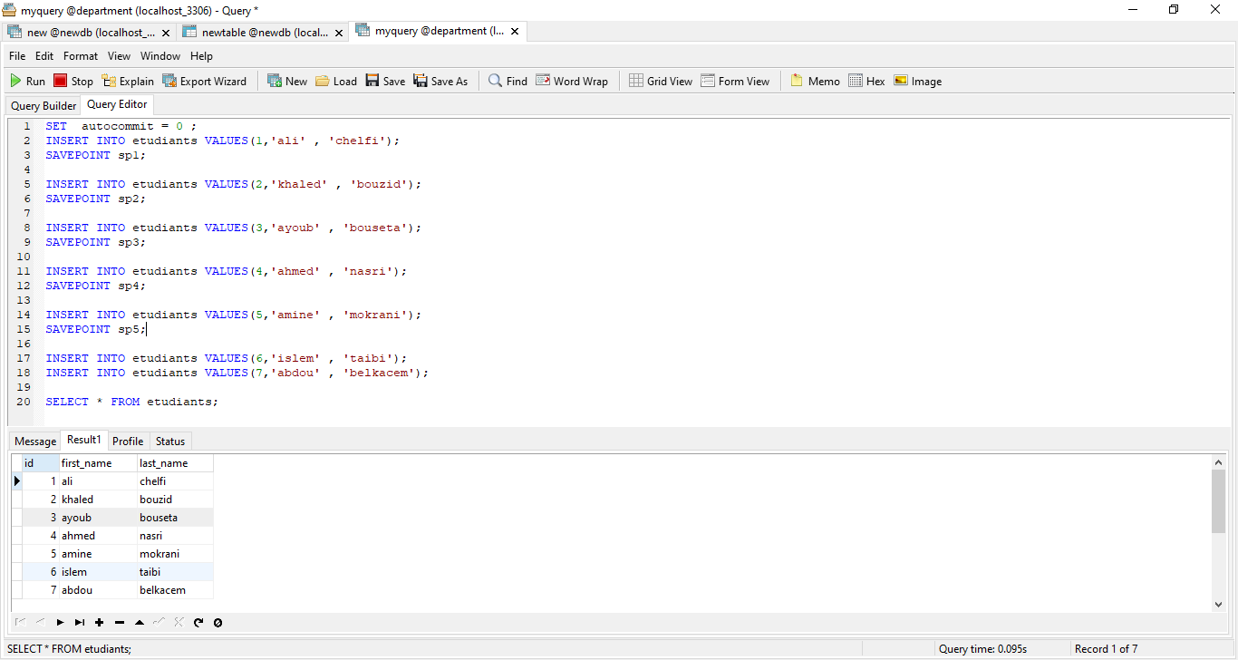

In the last picture we have seen how to use “ commit and savepoint” , now we will see how can we use the savepoint with rollback .

* Lets rollback to sp5 , the savepoint we have created .

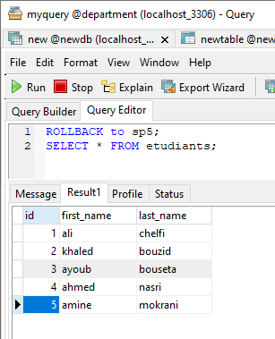

* And now try to go back to sp4 .

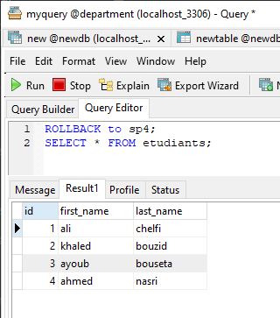

* Then try to rollback to sp2 .

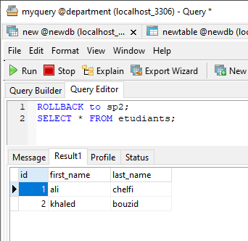

* Then try to rollback to sp3 .

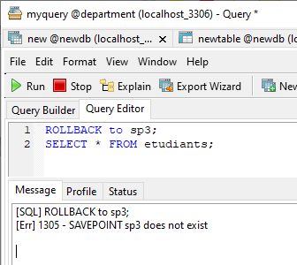

When we tried to switch to sp3 after we moved to sp2, the result was "savepoint sp3 does not exist" because it was deleted when we wrote "ROLLBACK to sp2".

* When we write “ROLLBACK;”, the table will be empty because we get back to the start point .

